Old Time Auction Co

Rushmore Mall/Traders Market

Rapid City SD

November 16th @ 1pm

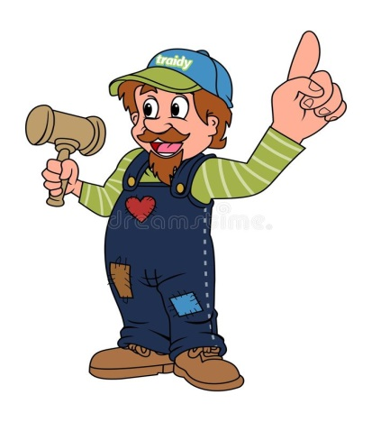

These items will sell at our next auction plus much much more; Star Wars 1970 thru present items, Star Wars helmet, hotwheels, Elvis Presley collectiables, Charlie Weaver bartender, coins, advertising items, stamps, trading cards, depression glass, carnival glass, pattern glass, large costume masks, tools, beer pong table, police patches, tyco train dump ore trailer, 7up plush snowman, plush Winnie the poo and Tiger, jewelry, furniture, queen and twin bedding, xbox rock band, old kerosene brass lamp, Pez dispensers, jersey nfl cards, Fran Tarkenton HOF 86 autographed football, Bobby Valentine autographed baseball, book shelves, bbq grille, pub table and 4, couch, and much more.

All items sell at absolute auction , AS IS WHERE IS.